D/C Meds Focus Call
July 22, 2020
12pm CST

Welcome and introductions were made
Great discussions
- Barriers and solutions
  - Discharged from other services
    - Process change – standardized D/C meds on patients who have been seen by vascular services.
    - BPA (best practice alerts in Epic) – Codes are tied to EMR to alert a vascular patient.
  - Other services compliance
    - Need physician champion and their buy-in
    - Education
The VQI guideline for discharge meds is evidence-based and calculated on a patient taking a statin and ASA or antiplatelet.
The use of ASA/antiplatelets with chronic anticoagulants is not contraindicated (unless the pt has a documented bleed, allergy, etc.).
The research has been done on statins and anti-platelets and that’s why the variable that is reported on in the biannual reports is compliance with those d/c meds. As long as an ASA is ordered with the anticoagulant or those meds are contraindicated, then they are following evidence based practice from the SVS. Also, don’t forget that stains are included because studies have shown that 82% of people with PAD have underlying CAD.
https://www.jvascsurg.org/article/S0741-5214(13)02284-2/fulltext
https://www.jvascsurg.org/article/S0741-5214(18)32674-0/fulltext
Five year survival chart: https://www.vqi.org/wp-content/uploads/DC-Meds-Flyer_web.pdf
  - Vascular surgeons and PVI practitioners do not want to prescribe D/C Meds because they feel the Primary Medical Doctor (PMD) should do that.
    - Suggestions/successes – used letters from the templates on the website to send to the PMD to let them know the patient was being started on those meds. Also, reminded to use the website as a resource – badge buddy, etc.
  - Discrepancy between D/C summary vs. physician orders
    - Solution – Nurses were educated to refresh D/C summary after the physicians add medications.
- Discussion regarding other registries and ASA/anti-coagulant – Cath PCI and NCDR now automatically contra-indicates ASA if the patient is prescribed an anti-coagulant. Cheryl to take back to the clinical team. However, as stated above – the VQI D/C meds variable is evidence-based and calculated on a patient taking a statin and ASA or antiplatelet.
- The Badge Buddy was discussed and shared. Here’s the most current version:

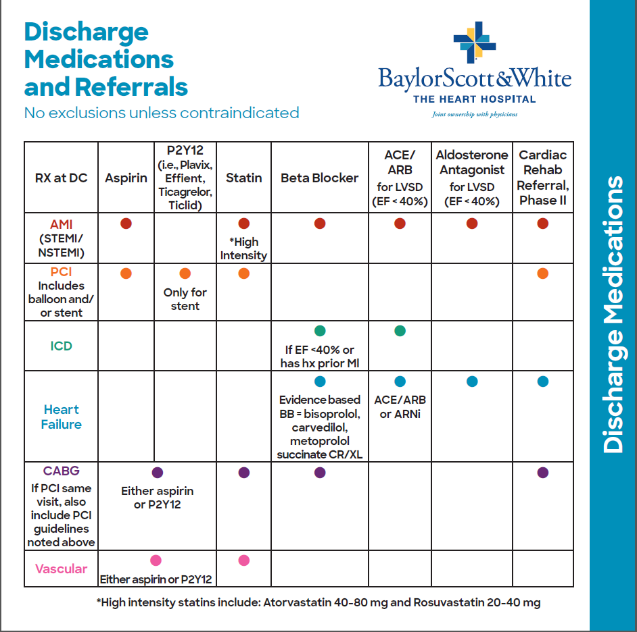

Back of Badge Buddy:
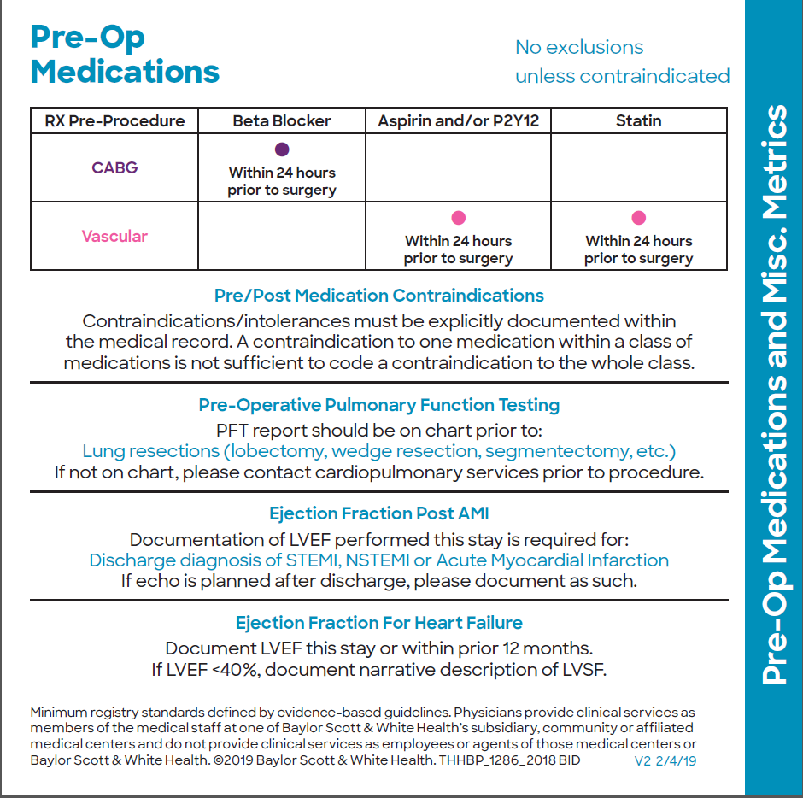

Next meeting scheduled for Wednesday, Sept 23, 2020 at 12n CST. 4th Wednesday every 2 months. Please feel free to forward the invite or share the below access information to anyone you think should join us.
Topic: D/C Meds Focus Call
Join from PC, Mac, Linux, iOS or Android: https://meetings.ringcentral.com/j/1484981124
For the best audio experience, please use computer audio.
Or iPhone one-tap :
US: +1(312)2630281,,1484981124#
+1(773)2319226,,1484981124# (US North)
+1(470)8692200,,1484981124# (US East)
+1(646)3573664,,1484981124#
+1(213)2505700,,1484981124#
+1(346)9804201,,1484981124#
+1(469)4450100,,1484981124# (US South)
+1(623)4049000,,1484981124# (US West)
+1(650)2424929,,1484981124#
+1(720)9027700,,1484981124# (US Central)
Or Telephone:
Dial(for higher quality, dial a number based on your current location):
US: +1(312)2630281
+1(773)2319226 (US North)
+1(470)8692200 (US East)
+1(646)3573664
+1(213)2505700
+1(346)9804201
+1(469)4450100 (US South)
+1(623)4049000 (US West)
+1(650)2424929
+1(720)9027700 (US Central)
Meeting ID: 148 498 1124
International numbers available: https://meetings.ringcentral.com/teleconference

Minutes will be posted on website

