DC Meds Focus Call

May 27, 2020

12pm CT

1. Welcome and introductions. Thanks for all who were able to attend.
   1. Everyone was encouraged to share their experience regarding COVID-19. Some are being re-assigned and furloughed, which is resulting in putting VQI and QI projects on hold.
   2. Many centers are starting to perform elective cases and seeing patients in the office for routine follow-up.
      1. Cheryl told group that the PSO is aware of these scenarios and are working on ways to address these situations. An announcement was released April 9th with details of the VQI and Pathways response to COVID-19.
      2. Discussed Online VQI@VAM.

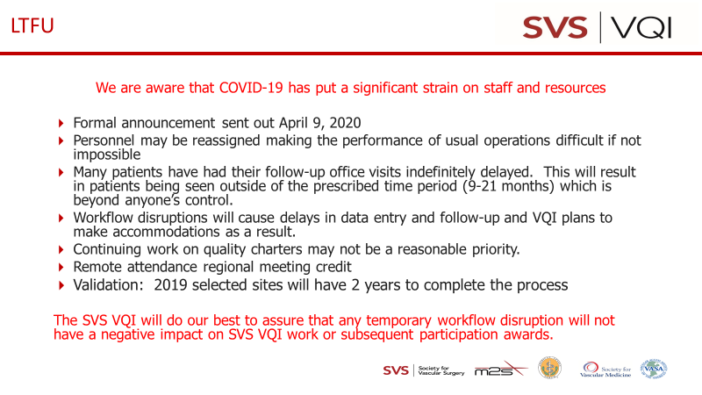

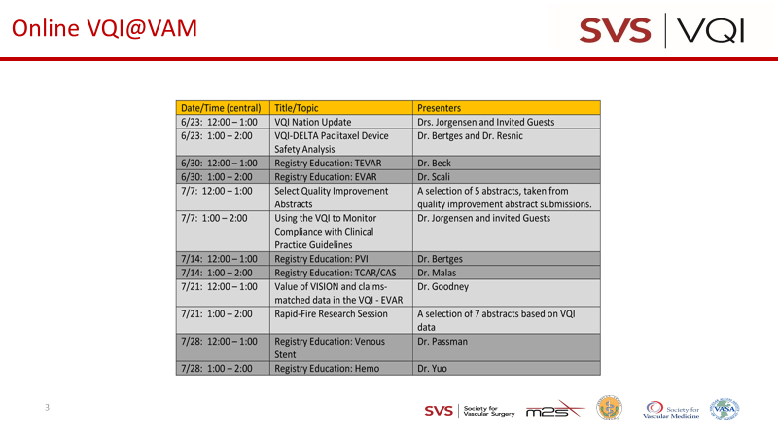

1. Round table discussion:
   1. Successes
      1. Utilizes the sample letters provided on the vqi website <https://www.vqi.org/resources/discharge-medication-communications/>
      2. One center uses Epic Smart notes to capture needed fields and was willing to share the following with anyone who was interested. The Epic UserWeb link:  <https://userweb.epic.com/Account/Register>

I found the registration to be a little trickier than expected so if the above link doesn’t work then try typing in “epic userweb” in google and then clicking on the “Epic UserWeb Registration” option:

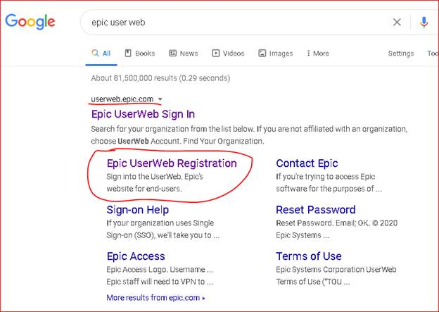

Once you have registered (for free) and are in then, go to the “Community Library” and search for SmartTexts or SmartForms on the topic you want.

* 1. Another center uses an Epic and VQI build
  2. Updated Badge Buddy – shared by Rosha Nodine (see below)

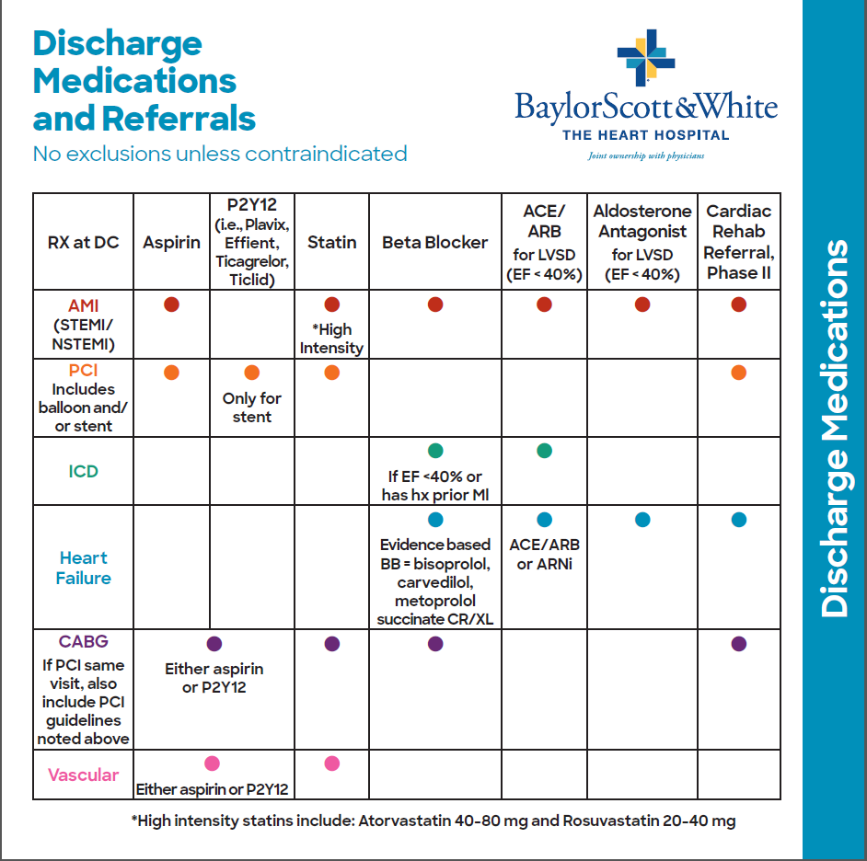

Back

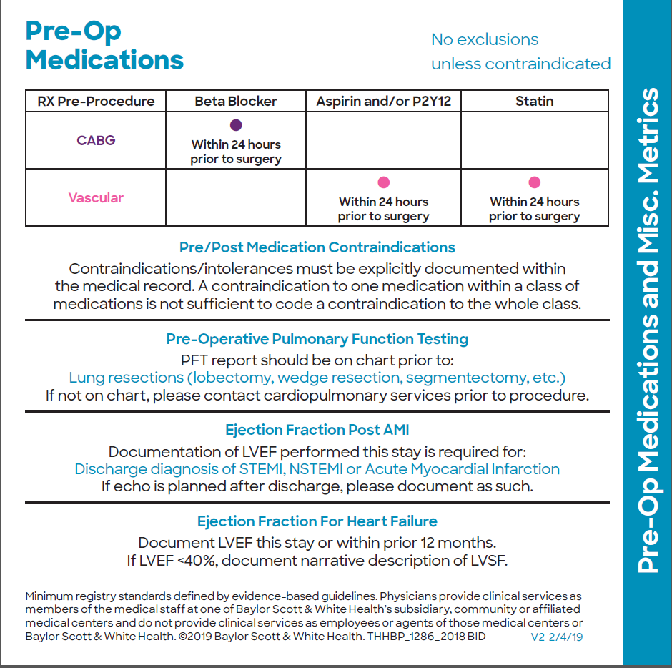

* 1. Ritu Sitaula shared the Smart phrases her center uses:

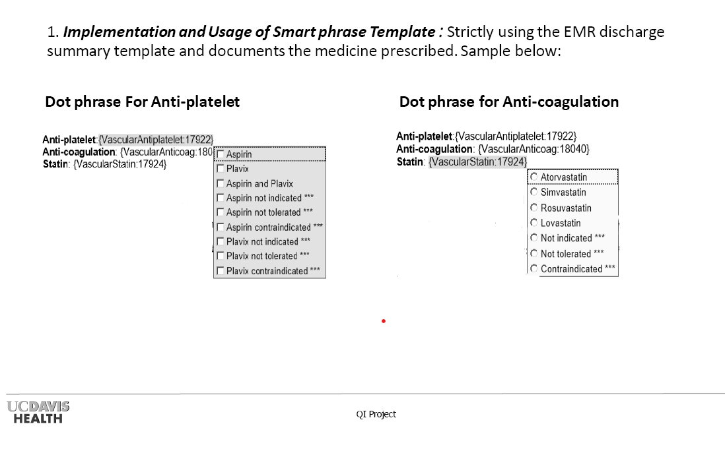

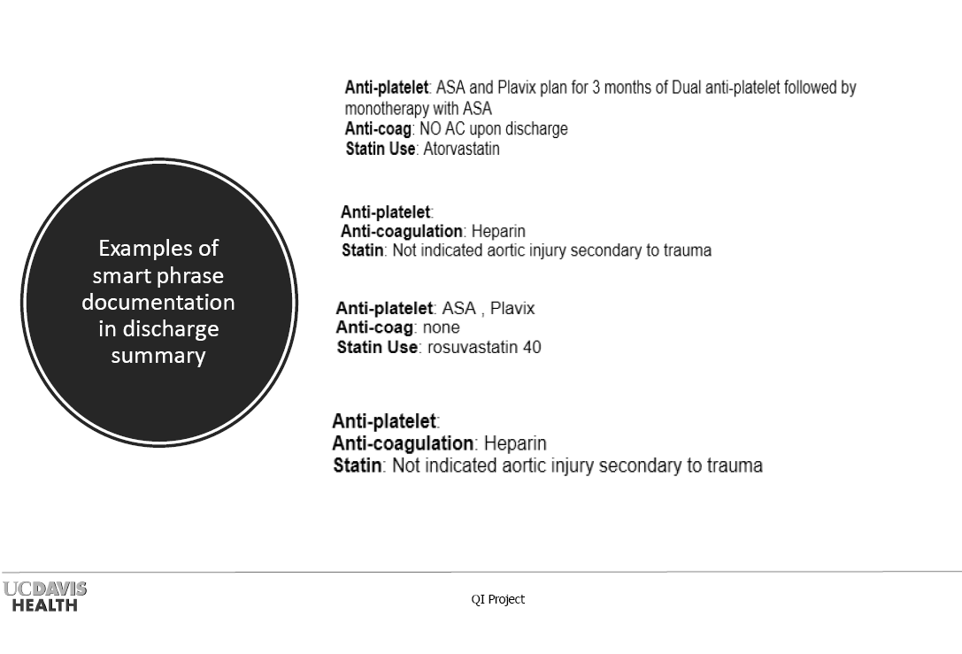

1. Sustaining
   1. Look at the dashboards and disseminate
   2. Get an alert when patient is discharged without DC meds. They look review chart to see why (could be contra-indicated). If not, NP is alerted, she prescribes and the D/C meds are updated in the chart. This center is <14 days out with abstraction and can act on it.
   3. DC meds are in the post-op order sets

BIG THANK YOU to all of those who shared. Great discussion!!

Next meeting scheduled for July 22, 2020 at 12N CT (4th Wednesday every 2 months)

Minutes will be posted on website

12 attendees