Clinical Focus Call
May 26, 2020
12pm CST
- Welcome and introductions. Even though the group was small (two) – the discussion was robust! Thanks!
  - Both shared their experience regarding COVID-19.
  - Centers are starting to perform elective cases and seeing patients in the office for routine follow-up.
    - Cheryl told group that the PSO is aware of these scenarios and are working on ways to address these situations. An announcement was released April 9th with details of the VQI and Pathways response to COVID-19.
    - Discussed Online VQI@VAM.
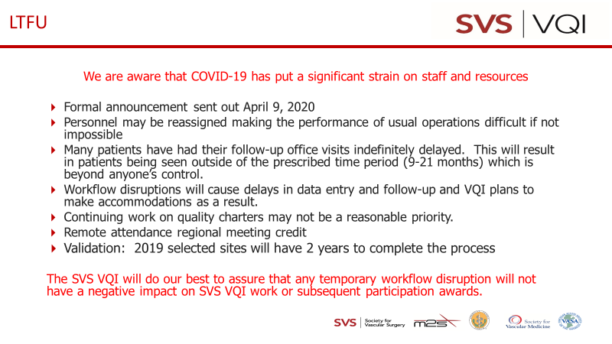
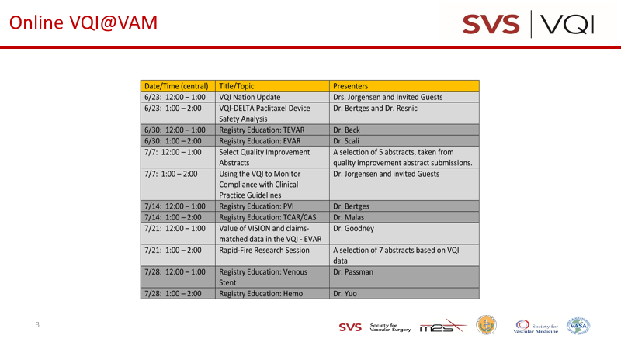

- Round table discussion:
  - In the process of developing protocols to focus on for their QI project; address blood pressure control, urinary retention (no catheter), and symptomatic headaches. Drill down if headaches are B/P related or surgical related.
Next meeting scheduled for July 28, 2020 at 12N Central Time (4th Tuesday every 2 months)
I need to cancel the current invite and re-issue a new invite with access information.
Minutes will be posted on website
2 attendees

