Documentation Focus Call
May 26, 2020
1pm CT
- Welcome and introductions. Thanks for all who were able to attend.
  - Everyone was encouraged to share their experience regarding COVID-19. Some are being re-assigned and furloughed, which is resulting in putting VQI and QI projects on hold.
  - Many centers are starting to perform elective cases and seeing patients in the office for routine follow-up.
    - Cheryl told group that the PSO is aware of these scenarios and are working on ways to address these situations. An announcement was released April 9th with details of the VQI and Pathways response to COVID-19.
    - Discussed Online VQI@VAM.
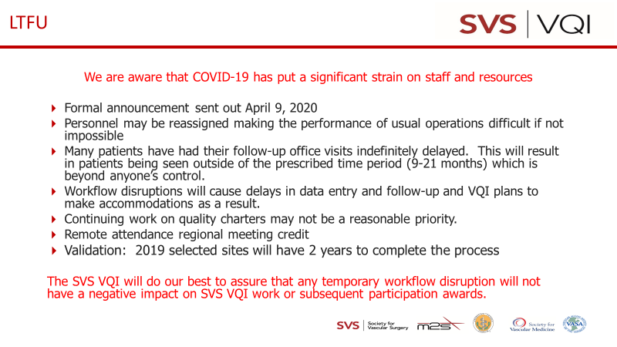
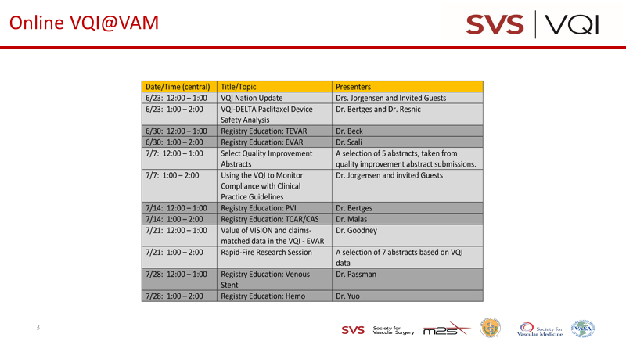

- Round table discussion:
  - One QI project is EVAR size compliance. FYI – there are many exclusions that contribute to this metric not achieving 100% unless those exclusions are taken into consideration and accounted for in tabulation. Exclusions can include; symptomatic, saccular, isolated iliac, need for transplantation, rapid expansion (>0.5-1.0 cm/year), etc.
  - Using #Hashtag in the comments section could be one way of capturing those cases for the center’s own internal use. You can filter the data using the “Data Download” feature.
  - If you’re interested in how the #hashtag works for regional projects are more in-depth projects, click on this link and go to Page 11. The rest of the guide is worth perusing, also https://www.vqi.org/wp-content/uploads/2019-QI-Project-Supplement-Digital-version.pdf
Next meeting scheduled for July 28, 2020 at 1PM CT (4th Tuesday every 2 months)
Minutes will be posted on website
3 attendees

