LTFU Focus Call

May 15, 2020

12pm CST

1. Welcome and introductions. Thanks for all who were able to attend.
   1. Everyone was encouraged to share their experience regarding COVID-19. Some are being re-assigned and furloughed, which is resulting in putting VQI and QI projects on hold.
   2. Many centers are starting to perform elective cases and seeing patients in the office for routine follow-up.
      1. Cheryl told group that the PSO is aware of these scenarios and are working on ways to address these situations. An announcement was released April 9th with details of the VQI and Pathways response to COVID-19.
      2. Discussed Online VQI@VAM.

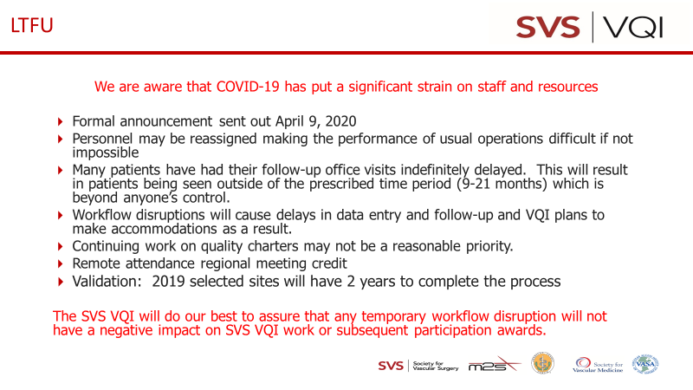

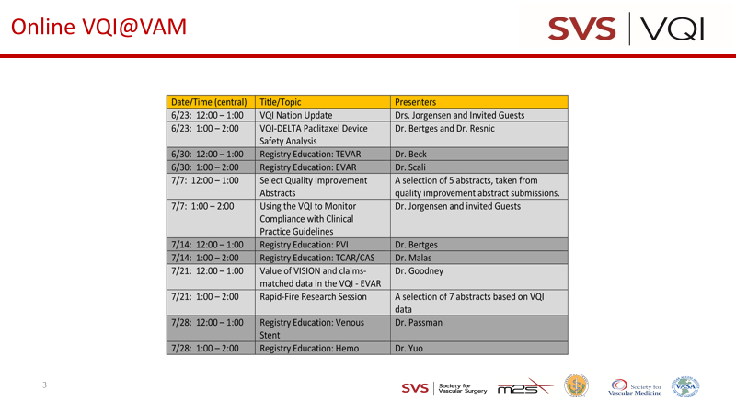

1. Round table discussion:
   1. Barriers
      1. IVC Filter follow-up. Many patients are trauma and once they leave the hospital there is no way to contact them.
      2. LTFU difficulty when the hospital is located in tourist spot. Patients do not live in the area and patients leave to go home. Contact lost with patient.
   2. Successes
      1. One center uses Epic Smart notes to capture needed fields and was willing to share the following with anyone who was interested. Thanks Lisha!!

The Epic UserWeb link:  <https://userweb.epic.com/Account/Register>

I found the registration to be a little trickier than expected so if the above link doesn’t work then try typing in “epic userweb” in google and then clicking on the “Epic UserWeb Registration” option:

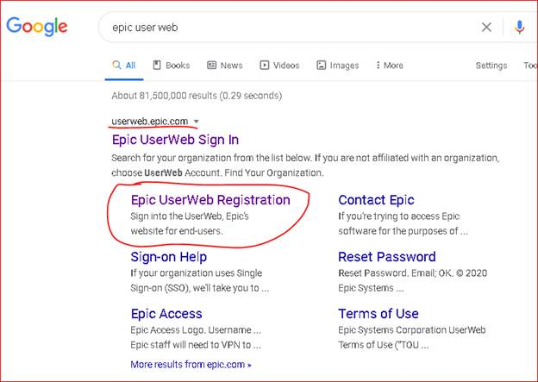

Once you have registered (for free) and are in then, go to the “Community Library” and search for SmartTexts or SmartForms on the topic you want.

1. CPT/ICD-10 codes are updated every year and the 2020 codes are in the Resources tab

Next meeting scheduled for July 17, 2020 at 12N CT

Minutes will be posted on website

10 attendees