D/C Meds Focus Call
January 22, 2020
12pm CST
- Review of the Members Only portion of the website, focusing on the Forums. This can be a great platform for networking. Stressed that the Forum is not to be used for clinical or data definition questions. All clinical questions need to be sent to Pathwayssupport@m2s.com to ensure an updated FAQ and ensure consistency in the interpretation of the VQI variables. The Forums are monitored by Cheryl. If you don’t get a response in a timely manner, please email cjackson@svspso.org to alert Cheryl that you left a message.
- There are many resources on the website (vqi.org) for any type of QI project.
- Discussed the Badge Buddy that was created by Rosha Nodine (Baylor). Here’s a link https://www.vqi.org/wp-content/uploads/secure/1495225258e92864772e796a67dad5909d7dcc285a.pdf and screen shot of it:
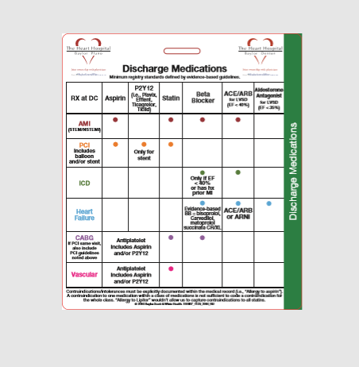
- Round table discussion
  - One center made a storyboard for education on DC Meds. Shared with PAs, MDs, NPs.
    - One center has tied results to an incentive program. Addendum – There’s a really good presentation from the 2019 VQI@VAM meeting that discusses one center’s success with this topic: “Meaningful Use: Linking Physician Compensation to Vascular Quality Initiative Metrics” by Scott S. Berman, MD, MHA, RVT, FACS, DFSVS and Megon L. Berman, BS from Pima Heart and Vascular (Tucson, Arizona). https://www.vqi.org/wp-content/uploads/secure/15635045630c5b2bc216b8b9a330d59384431e5652.pptx

- Next meeting scheduled for March 25th at 12n CST
- Minutes will be posted on website
6 attendees

