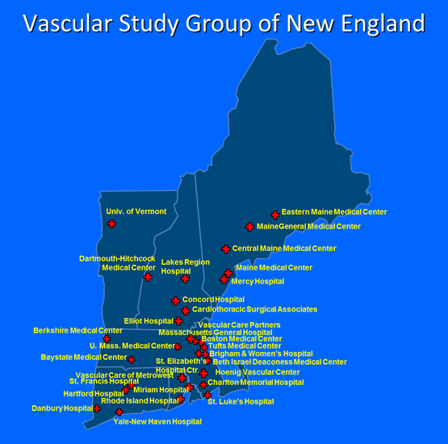
Vascular Study Group of New England
Quality Improvement Project (QIP)
Award Program
Goal: To encourage and support quality improvement research in the Vascular Study Group of New England.
Eligible Applicants: Any clinician or data support team member who is a member of the Vascular Study Group of England. Physicians, physician assistants, nurses and nurse practitioners, data analysts, quality improvement team members, and students of all these disciplines are eligible to apply.
Deadline for submission: Friday, March 31, 2023
Award Announcements: Friday, April 21, 2023
Program Summary: The VSGNE was founded in 2001 as the Vascular Study Group of Northern New England, with the mission to improve the quality, safety, effectiveness, and cost of vascular health care by collecting and exchanging information.
A central element of achieving this goal is the pursuit and performance of quality improvement projects and research related to quality improvement in vascular care.
To help its members achieve these goals, the VSGNE will support several Quality Improvement Project Awards in 2023 as part of the VSGNE Quality Research and Improvement Project Award Program. This program will issue up to five Quality Improvement Project Awards in Spring 2023.
Applications for these awards should detail how the funds will be used to advance the quality of care for patients with vascular disease at their centers in New England. The application should have the following sections:
- Innovation:
  - Detail what challenge your work will address, and what is new and innovative about your idea (1 page).
- Approach:
  - Describe how you will execute the project and what you will use to measure the impact of your work (1 page).
  - Include timeline and deliverables
- Personnel:
  - Describe personnel, hours per week, and budgetary requirements
- Challenges and Limitations:
  - Outline what challenges you may encounter, and what limitations may exist after your project is completed (1 page).
- Budget:
  - A budget of up to $10,000 for the project should be included. Capital and personnel needs should be described, and individual budget elements will be reviewed by VSGNE personnel. Attending physician salary support is not permitted as part of research budgets.
Submission Instructions:
Applications must include a VSGNE member and be submitted via email to Leka Johnson (ljohnson@svspso.org) by the deadline shown above. Those accepting VSGNE QIP awards must be prepared to present a report at the Spring or Fall 2023 VSGNE Regional Meetings. The SVS PSO will consider all VSGNE Quality Improvement Projects for inclusion in the VQI Annual Meeting as a Poster or Podium presentation.

