

**VQI ONLINE Annual Meeting Registration Flow:**

While there will be no fee for the VQI Online sessions, you do have to register for the event. Once you register, you will have access to all 12 educational sessions. This guide will walk you through how to register for the event and how you will access each educational session.

1. From the SVS ONLINE Website: <https://vascular.org/svs-online>/registration click REGISTER NOW!



If you are not logged in, you will be prompted to enter your AA username and password. You may need to create an account. Please do this by clicking “New Customer”.

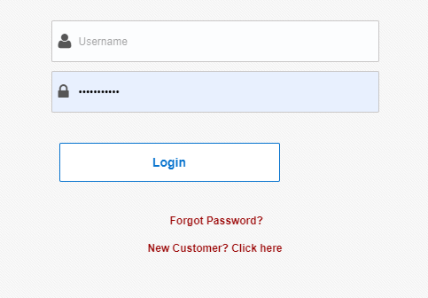

2. You will then be directed to the below landing page. All four SVS ONLINE events will appear on this page.

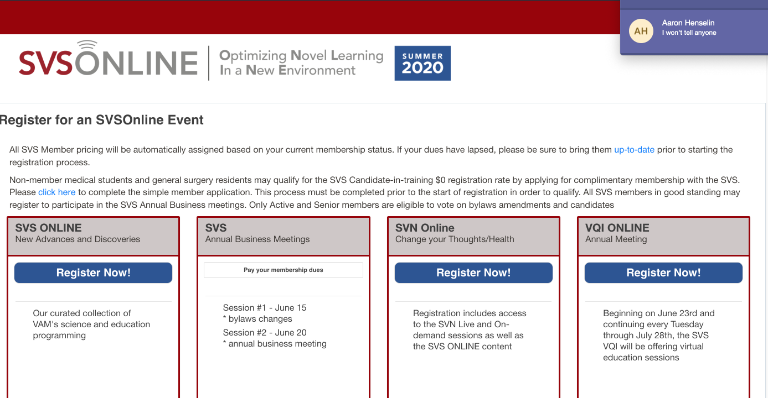

3. Click Register Now! Under the VQI ONLINE event.

4. You will be prompted to select your profession as well as agree to the SVS ONLINE Registration Terms and Conditions (please note that you if you register for more than one event, you will only need to accept the Terms and Conditions on your first registration). Then, click **SAVE** to move to the next page.

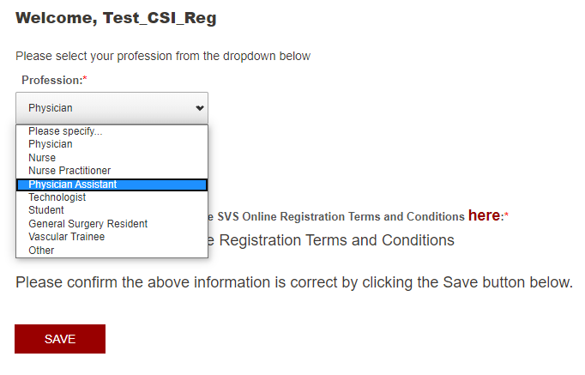

5. The next page will provide a summary of what event you are registering for as well as the dates the event will be held. You will also be able to review and update your contact information:

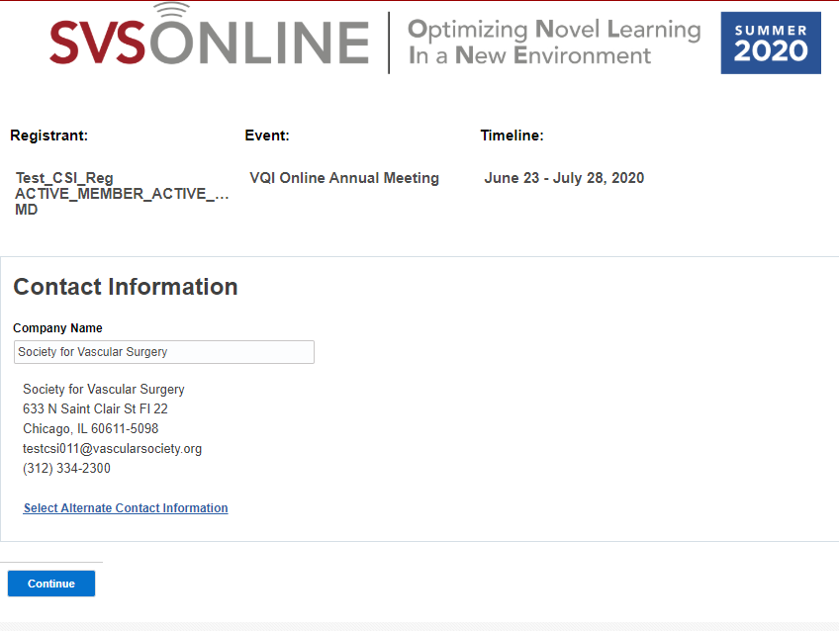

If you need to update your contact information, please click the link which will allow you to make updates to your address, email, and phone number:

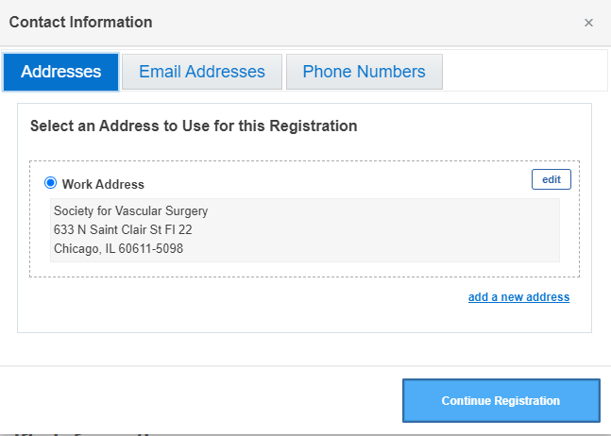

When you are finished, click **Continue Registration**. This will take you back to the previous page to continue your registration. Click **Continue** to move to the next page.

6. The next page provides a summary of your contact information as well as your registration information, including pricing:

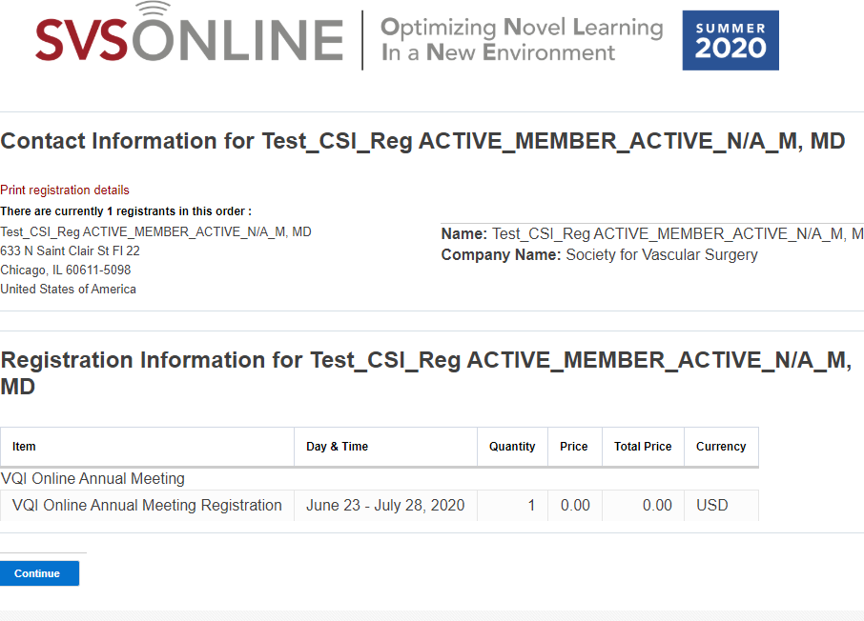

Click **Continue** to move to the next page.

7. The next page provides your shopping cart contents. On this page you are able review what is in your cart, add more events to your cart and make an optional donation**. If you are only registering for VQI ONLINE, you will not be charged a fee and will not have to enter any credit card information.**

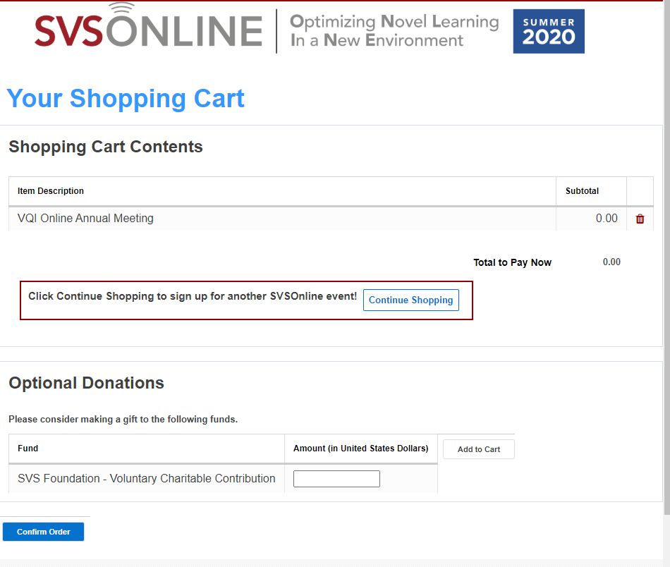

If you wish to add more events to your cart, please click  which will bring you back to the landing page which will allow you to register for more events. You will go through the registration process again for that event and it will then be added to your cart on this page.

If you wish to make an optional donation, you can enter the amount and then click Add to Cart. That donation will then be added to your cart on this page.

If you did not add another event or donation to your cart, just click **Confirm Order**.

If you did add another event or donation to your order, there is a drop down to select how you wish to pay

7. Once you submit your payment for your registration, you will receive two emails:

a. “Your Payment Details”:

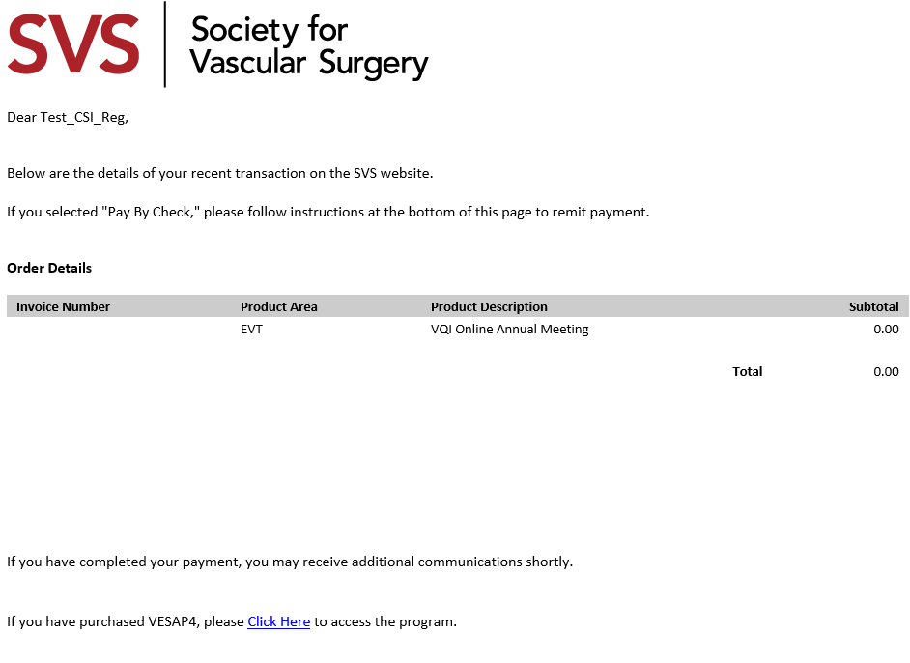

b. SVS ONLINE Thank You Email:

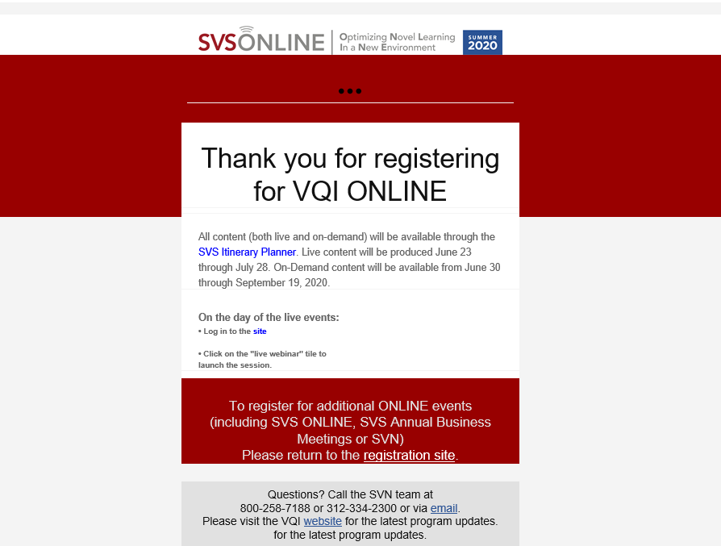

Click the “SVS Itinerary Planner” to be directed to the Online Content Management page.