Once you have registered for the VQI Online, as detailed in the registration instructions, you will receive a thank you confirmation email. If you have not received the confirmation email, please be sure to check your spam/junk email folders.

SVS ONLINE Thank You Email:
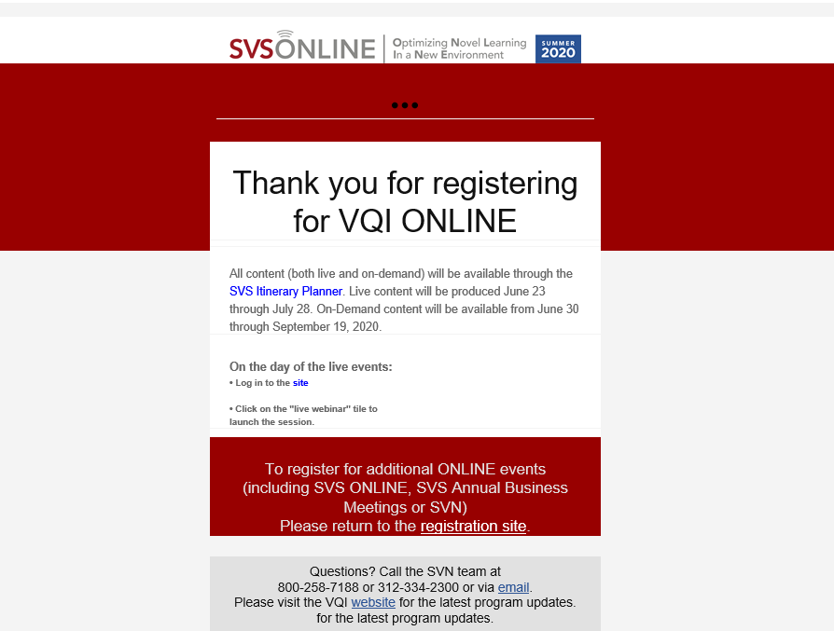

Click the “SVS Itinerary Planner” link to be directed to the Online Content Management page. Please note that Chrome and Firefox are the recommended internet browsers for the Itinerary Planner.

If you have registered but cannot find your thank you confirmation email, here is an alternate way to get to the VQI Online Content Planner. Please enter the following link into your web browser: https://vascular.org/svs-online/program. You will be taken to the following page. Please note that you may be asked to re-enter your username and password, created at the time of registration.

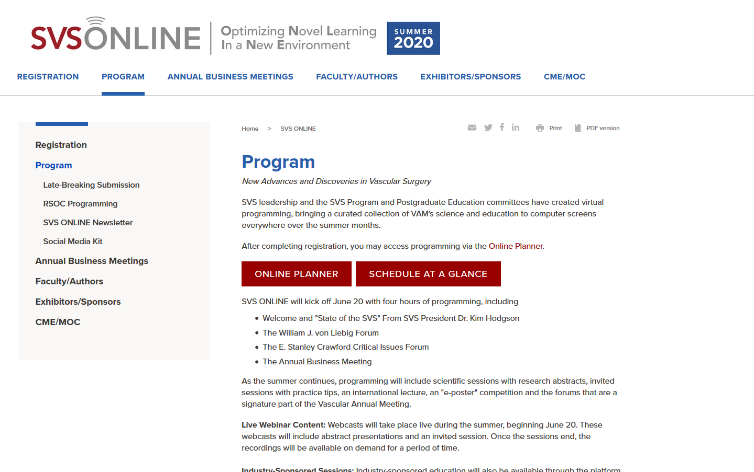

Click the ONLINE PLANNER button. Please note that Chrome and Firefox are the recommended internet browsers for the Itinerary Planner.

Once on the SVS ONLINE Content Management page click VQI ONLINE, which is located in the left-hand navigation column.

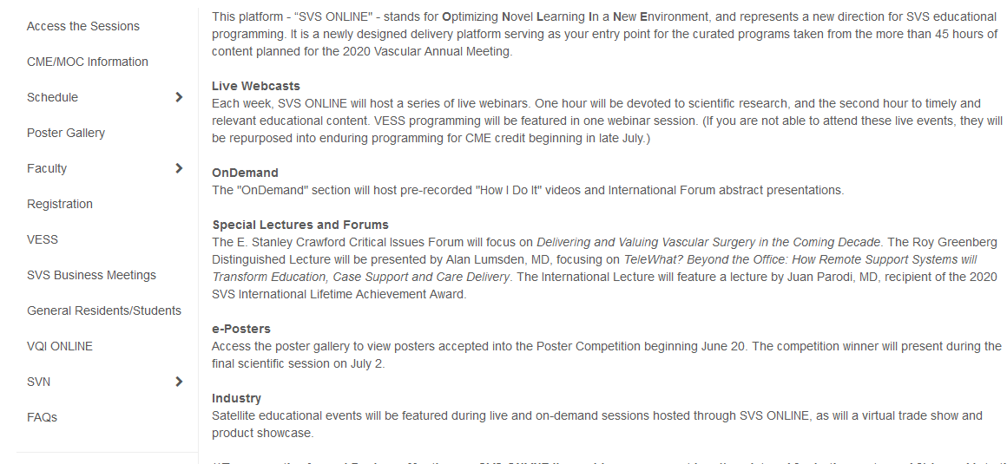

After clicking on VQI ONLINE, you will be taken to the VQI ONLINE Content Planner. It is through this page that you will be able to access links to the live events, pre-event materials and recordings of events that have been completed. There will be one active link for each day’s events, so you will not have to log into a new webinar to attend the second session of each day.

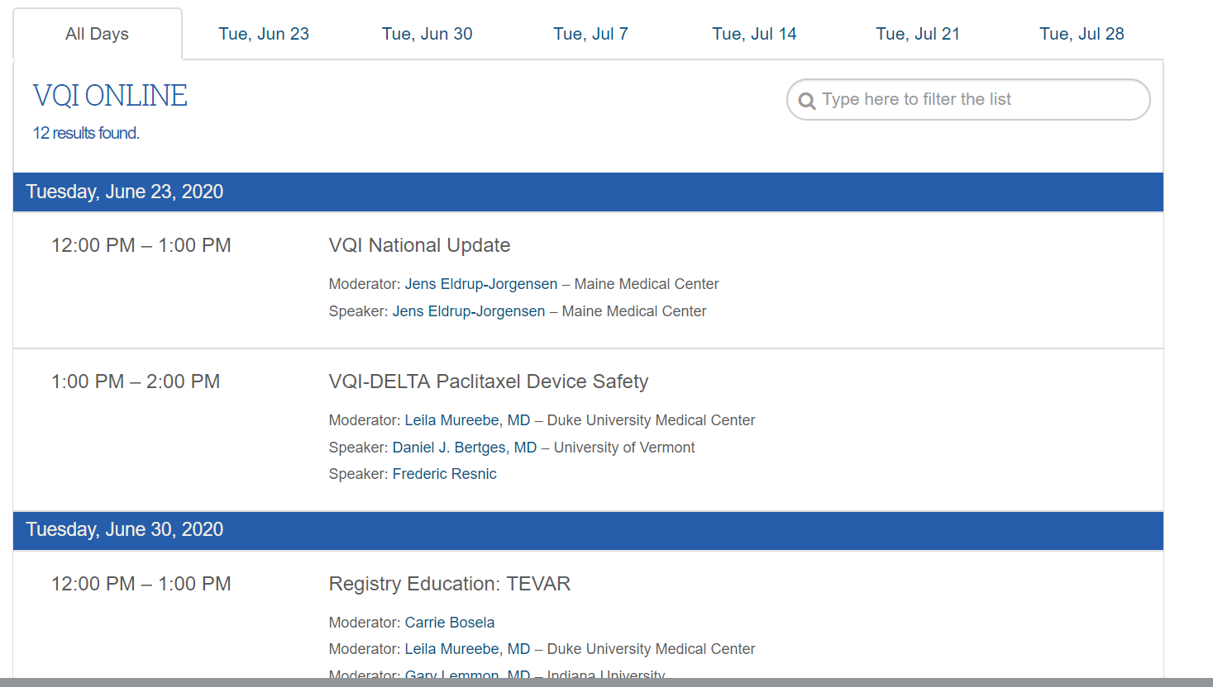

Click on the session title to gain access to additional information, including speakers, pre-event materials and the link to the live event.

Once you have clicked a session title, you will receive a pop-up window with additional session information. It is from this window that you will be able to access pre-event materials and launch the live stream on the day of the event. Please remember that you have to be logged in using your username and password for the SVS website. The Live Stream button will become active about 1 hour prior to the start of the live event.

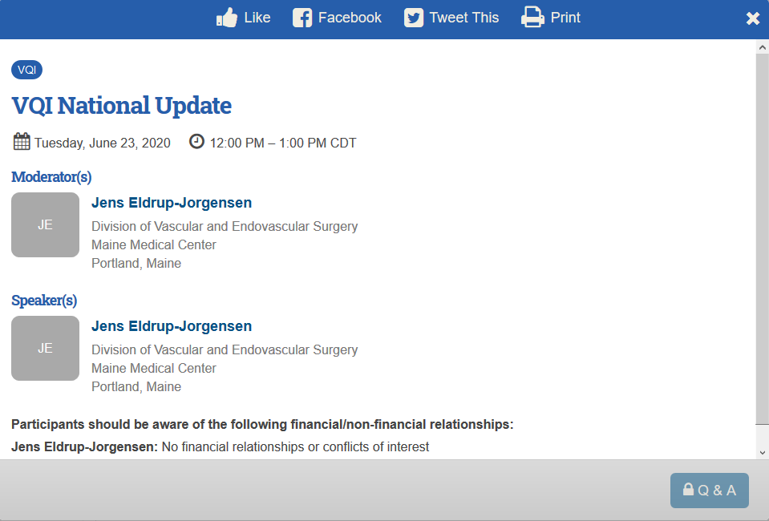
PDF
Live Stream
PowerPoint

