(DATE)
Dear Dr.____________________,
We had the pleasure of participating in the care of ______________________________ while _______________________ was hospitalized recently at ____________________ hospital. In our medication review we noticed our patient is not on anti-platelet therapy. Anti-platelet therapy has been shown to be beneficial in reducing the risk of myocardial infarction, stroke and vascular death in patients with symptomatic peripheral arterial disease.^{1,2} This benefit has been shown extend to patients undergoing carotid surgery, lower extremity bypass surgery, and abdominal aortic aneurysm surgery.
Accordingly, during the hospitalization, we started our patient on aspirin 81 mg daily. We ask for your assistance in monitoring for the very rare complication of bleeding in your future office visits with our patient.
This initiative to optimize anti-platelet use in patients with vascular disease is a component of the Southern California Vascular Outcomes Improvement Collaborative (So Cal VOICe), in which I am a member and active participant. The So Cal VOICe is a regional voluntary cooperative group of vascular disease specialists dedicated to improving outcomes and advancing the care of vascular patients. Our regional group is part of a national network of quality improvement organizations sponsored by the Society for Vascular Surgery.
As always, if you have any questions please contact me at _____________, and I would be happy to speak with you.
Sincerely,
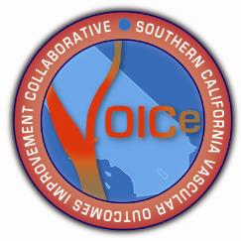

http://www.vascularqualityinitiative.org/
- !ntithrombotic Trialists’ Collaboration. Collaborative meta-analysis of randomized trials of antiplatelet therapy for prevention of death, myocardial infarction, and stroke in high risk patients. BMJ. 2002;324:71-86.
- Catalano M, Born G, Peto R. Prevention of serious vascular events by aspirin amongst patients with peripheral arterial disease: randomized, double-blind trial. J Intern Med. 2007;261:276-84.

