Request to SoVONet Advisory Committee for Non-Identifiable Dataset
Send to william.shutze@baylorhealth.edu

Name of Requesting Investigator:
Email Address:
Project Name:
Date of Request:

Context and Research Question (4-5 sentence summary that will be distributed to each center for approval):

Non-identifiable dataset(s) being requested(includes follow up data):

Carotid Endarterectomy
Carotid Artery Stent
Open AAA Repair
Endovascular AAA
TEVAR/Complex EVAR
Suprainguinal Bypass
Peripheral Vascular Intervention
Hemodialysis Access
Lower Extremity Amputation
IVC Filter
Varicose Vein

Infrainguinal Bypass

Year(s) for which data are requested:

Blinded center-specific data needed to analyze follow up data as well as procedure data:
No Yes

Blinded center-specific data needed: No Yes if yes, explain how/why this will be analyzed:

Blinded surgeon-specific data needed: No Yes if yes, explain how/why this will be analyzed:

Inclusion/exclusion criteria: (list variables to be used. e.g., age<80 years)

Exposure variable(s): (e.g., asymptomatic carotid stenosis)

Outcome variable(s): (e.g., in-hospital stroke after CEA)

Mock Tables: These tables will help the RAC evaluate your research plan. Please include, for instance, the key patient characteristics (in rows) by your primary exposure (in columns), e.g. the usual Table 1 in a manuscript. Please also include a table displaying your main outcome measures (in rows) by your primary exposure variable (in columns).

This Data Use Agreement (the “Agreement”) is made this _____ day of _____, 2015 by and between Society for Vascular Surgery Patient Safety Organization (“SVS PSO”) and Dr. ________________(“Recipient”).

SVS PSO will provide a non-identifiable data set for project ”(The Project) to Recipient on the condition that Recipient agrees to the following by signing this form:

- The Recipient shall not use or further disclose the data set other than as required to complete The Project.

- The Recipient shall allow access to the data only to individuals directly accountable to the Recipient.

- The Recipient shall use appropriate safeguards to prevent use or disclosure of the data set other than as permitted by this Agreement.

- Upon completion of the project, or should this Agreement be terminated for any reason, including, but not limited to Recipient’s decision to cease use of the data, Recipient agrees to destroy or return all data provided pursuant to this Agreement. VSG PSO will maintain a copy of each data set indefinitely for future reference by the Recipient.

- The Recipient shall submit a six month progress report of approved project to the VSGNE RAC Chair and submit approved project to the VSGNE Executive Committee for consideration for presentation at the biannual meeting.

SVS PSO Recipient

Name (print): __Carrie Bosela____________ Name (print): ___________________

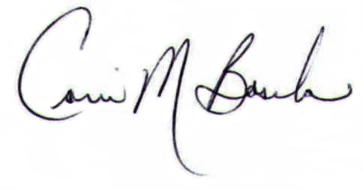
Title: SVS PSO Administrative Director Medical Center:___________________

Signature: __________________________ Address:_________________________

Date:___________ ________________________________

Phone:___________________________

Email:___________________________

Signature: _______________________

Date:___________

