What the Society for Vascular Surgery wants you to know about smoking

The Society for Vascular Surgery (SVS) recognizes that quitting smoking is one of the most difficult addictions to overcome. The SVS is committed to our patients to assist them in their struggle to stop smoking. The benefits of stopping smoking are clear. Within hours, carbon monoxide levels begin to disappear and oxygen levels in your blood begin to improve. Sense of taste and smell begin to return within the 1st week and your risk of having a heart attack is dramatically reduced by one year. After 10 years of not smoking, your risk of serious lung disease is low.
The most important decision in whether to stop smoking is the decision to quit and setting a target date for stopping. The SVS has put together a list of useful websites and resources packaged together in our Patient Toolkit to aid you in your path to achieve success in stopping smoking. Don’t be discouraged. Most smokers start trying to quit at least 6 times before they are finally successful. There is no right way to quit. You may have to try different methods before you find the one that works for you. By doing so, you have made one of the biggest improvements to improve your health, improve your outcomes in your vascular disease and improve your overall quality of life.
Please use the aids listed below and those in the Patient Toolkit which you may find helpful. As always, the SVS and your vascular surgeon are here to help in any way we can including prescribing medications, nicotine patches or lozenges or referral for smoking cessation counseling if needed.

Need help to Quit Smoking?
Things to remember:
- It’s OK to fail or “fall off the wagon”. Most smokers make at least 6 attempts at quitting before they are successful at stopping.
- It’s never too late to quit. Health benefits are found even for those with advanced heart or lung disease. The earlier you quit, the better you’ll feel.
- There is no ideal or best way to quit smoking; this varies with each person. The best way to quit smoking is the one that works for you, and you can stick with.
- Chances of success increase with a strong support system. Encourage others ‘commit to quit’ with you. Create a non-smoking environment around your work and home if possible.
- Making strict no smoking rules in your house and your car increases your chances of quitting and protects you from others who continue to smoke. Please see link below under “Helpful Society and Organization Websites” for information on second hand smoke.
- Smokeless tobacco (snuff, chew) also carries significant risks. Please see link below under “Helpful Society and Organization Websites”.
- For information about how smoking affects your vascular disease please (see the attached document)

How Much Do You Pay?
Average of $6.00 Dollars/pack
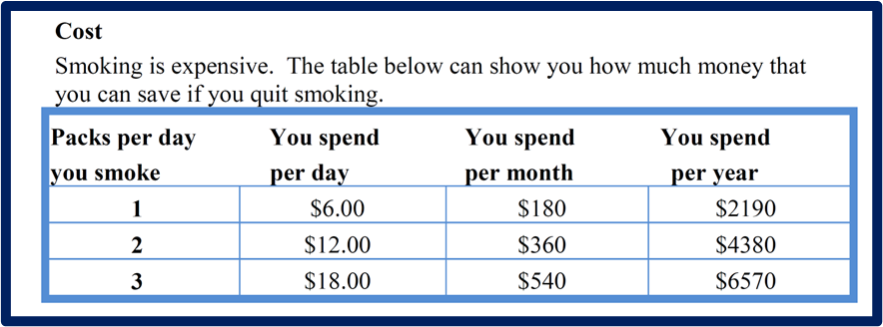

Resources available to you on quitting smoking:
Local:
- Check with your vascular surgeon. Many hospitals/health care centers now provide smoking cessation services with Tobacco Treatment Specialists on site.
- Support groups may also be available with others attempting to quit. They can provide helpful hints to manage your cravings for a cigarette.
State:
- Each state provides a quit smoking program with information on maintaining abstinence from tobacco. Smoking cessation “coaches” can also provide over the phone support.
- 1-800-QUITNOW will connect you to begin the program which is free of charge.
- Nicotine patches, gum and lozenges can also be supplied free of charge with program participation in most states.

Helpful Society and Organization websites:
- US Dept. of Health and Human Services: https://www.smokefree.gov.
- American Heart Association-5 Steps to Quit Smoking and Vaping: https://www.heart.org/en/healthy-living/healthy-lifestyle/quit-smoking-tobacco/5-steps-to-quit-smoking.
- FDA approved medication to quit smoking: https://www.fda.gov/consumers/consumer-updates/want-quit-smoking-fda-approved-and-fda-cleared-cessation-products-can-help.

- American Cancer Society- Quitting Smoking: https://www.cancer.org/healthy/stay-away-from-tobacco/guide-quitting-smoking/quitting-smoking-or-smokeless-tobacco.html.
- American Lung Association-Quit Smoking: https://www.lung.org/quit-smoking.
- Centers for Disease Control-Quit Start Phone App: https://www.cdc.gov/tobacco/campaign/tips/quit-smoking/quitstart-app/index.html.
- World Health Organization-Tobacco: https://www.who.int/news-room/fact-sheets/detail/tobacco.
- Second Hand Smoke: https://www.healthychildren.org/English/health-issues/conditions/tobacco/Pages/Dangers-of-Secondhand-Smoke.aspx.
- Smokeless Tobacco: https://www.rogelcancercenter.org/breaking-habits-beating-us/smokeless-tobacco

