How smoking affects your vascular disease

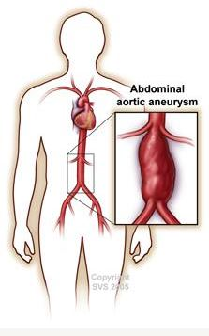
- Smoking increases your risk of developing an abdominal aortic aneurysm (AAA) up to five times higher than someone who has never smoked.
- Smoking can also make your AAA grow faster and be more likely to burst
- Quitting smoking makes it list like likely that you will develop an AAA
- Even if you smoke now, you can reduce your risk of developing a AAA if you are able to quit¹

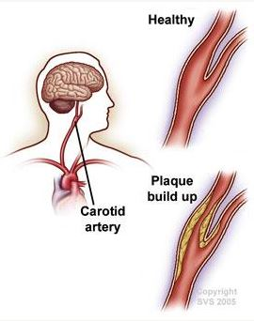
- Smoking increases your risk of stroke because it forms plaque that can block the carotid artery – which is the blood vessel that goes to your brain²
- The best thing you can do to reduce your risk of carotid artery disease and stroke is quit smoking²
- Once you quit smoking, the amount of carotid plaque buildup begins to slow.

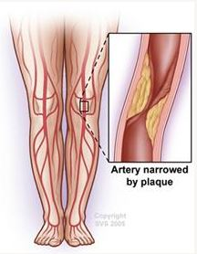
- Smoking does not only cause buildup of plaque in the arteries in your brain, it can also block the blood vessels that go to your feet. This is called peripheral artery disease (PAD)
- Half of all PAD cases are due to smoking³
- The most devastating result of PAD is amputation, which is much more likely to happen if you continue to smoke
- If you are smoking, the odds of your PAD operation failing and the odds that you will need an amputation is much higher than if you quit^{4,5}

Looking for a vascular specialist? Start here: vascular.org/find-specialist

References
- Aune, D., Schlesinger, S., Norat, T., & Riboli, E. (2018). Tobacco smoking and the risk of abdominal aortic aneurysm: a systematic review and meta-analysis of prospective studies. Scientific reports, 8(1), 14786. https://doi.org/10.1038/s41598-018-32100-2
- Stein, J.H., Smith, S.S., Hansen, K.M., Korcarz, C.E., Piper, M.E., Fiore, M.C., & Baker, T.B. (2020). Longitudinal effects of smoking cessation on carotid artery atherosclerosis in contemporary smokers: The Wisconsin Smokers Health Study. Atherosclerosis, 315, 62-67. doi: https://doi.org/10.1016/j.atherosclerosis.2020.11.010
- Wang, W., Zhao, T., Geng, K., Yuan, G., Chen, Y., & Xu, Y. (2021). Smoking and the Pathophysiology of Peripheral Artery Disease. Frontiers in cardiovascular medicine, 8, 704106. https://doi.org/10.3389/fcvm.2021.704106
- Young, J. C., Paul, N. J., Karatas, T. B., Kondrasov, S. A., McGinigle, K. L., Crowner, J. R., Pascarella, L., Farber, M. A., Kibbe, M. R., Marston, W. A., & Kalbaugh, C. A. (2019). Cigarette smoking intensity informs outcomes after open revascularization for peripheral artery disease. Journal of vascular surgery, 70(6), 1973–1983.e5. https://doi.org/10.1016/j.jvs.2019.02.066
- Armstrong, E. J., Wu, J., Singh, G. D., Dawson, D. L., Pevec, W. C., Amsterdam, E. A., & Laird, J. R. (2014). Smoking cessation is associated with decreased mortality and improved amputation-free survival among patients with symptomatic peripheral artery disease. Journal of vascular surgery, 60(6), 1565–1571. https://doi.org/10.1016/j.jvs.2014.08.064

